HOK Analysis Visualization Framework 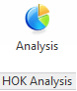

*(Updated 2013-09-10 by Jinsol Kim)*

## Overview

This package of AVF tools is designed to visualize mapped data on parameterized faces, curves, or free points. This package was sorted by three main disciplines, Urban Planning, Architecture, and Interior Design. Several tools exist under each discipline with different default settings for input data, and with different ways of visualizing the data.

* Urban Planning: Mass Analysis (Released), FAR Calculator (Released), Topography , Building Network
* Architecture: Façade Analysis, Heat Map
* Interior Design: Radiance Analysis, Field of View

## Common Features of Analysis Visualization Framework

The Revit API has ability to capture multiple associated values in each point, defining different names, descriptions and units on each data set of the Analysis Results. For example, if the analysis has time factors and its results vary depending on the point of time measured, the calculated values can be stored in multiple layers of dataset sorting them by times like 9:00 am, 12pm, 3pm, …. and so on.

One more option given to users is to control the appearance of the results. Users can create or modify the Analysis Display Style within the Revit UI and select a style that will be used for the current analysis results through the command windows of this AVF tool.

The results data is transient. The visualized data will last until the document is opened. After closing the document and reopening it, the data will be no longer to display in the view. It is recommended creating a screen cast before you loss the analysis data. For the current use, this tool is more supportive to two analysis display styles, Colored surface and Markers with texts.

Contents

Overview 1

Common Features of Analysis Visualization Framework 1

***1.*** ***Urban Planning*** 3

1.1 Mass Analysis 4

1.2 FAR Calculator 9

1.3 Topography (For Future Development) 15

1.4 Building Network (For Future Development) 16

***2.*** ***Architecture*** 17

2.1 Façade Analysis (for Future Development) 17

2.2 Heat Map (for Future Development) 17

***3.*** ***Interior Design*** 17

3.1 Radiance Analysis 17

3.2 Field of View 22

# ***Urban Planning***

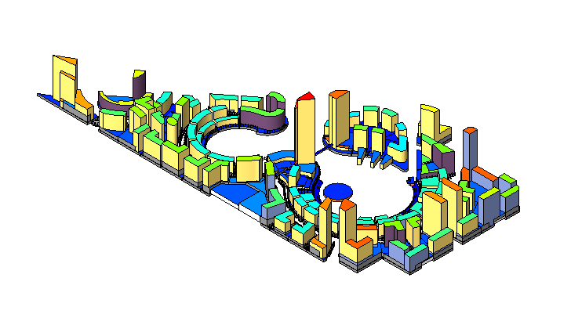

This tool will allow visualizing indexed data of urban scale on top of colored surfaces of selected input elements. The results can be directly imported from parameters values, or can be internally calculated with predefined rules using the geometrical attributes of model elements.

***Requirements***

The model should be prepared with 3D Mass elements represented as buildings and area elements for plots on which building elements are placed.

***Building Parameters (recommended)***

Building Footprint – Area

Parking Standard – Area

Building Height – Length

District Area – Area

Plot Area – Area

District Code – Number

Plot Code – Number

Population Density – Number

***Area Parameters (recommended)***

Building Footprint – Area

Parking Standard – Area

Building Height – Length

District Area – Area

Plot Area – Area

District Code – Number

Plot Code – Number

FAR – Number

Population Density – Number

Required FAR - Number

## Mass Analysis

In order to differentiate building elements by numeric values from a parameter of each building, by setting minimum and maximum values among the collected data, a range of colors according to the color index will be displayed on faces of building elements.

* + 1. ***Default Settings***

|  |  |
| --- | --- |
| Settings | Values |
| Default Category | Mass |
| Category Options | Mass |
| Default Parameter Selection | Building Height |
| Displaying Face on | Top |
| Allowance to Set Reference | False |
| Reference Category | Null |
| Reference Description | Null |
| Default Units | meters |

* + 1. ***Walkthrough***
* **Select a Revit category**: From the combo box, Category *to be analyzed*, select a category among the lists of categories. Mass Analysis provides only one category option, Mass.
* **Select a Parameter**: From the combo box, *Parameter for displaying values*, select a parameter that contains *double type* values (*). These values are extracted by the tool and mapped with corresponding colors depending on the numeric values. ( *) since only numeric values can be utilized for the data visualization, only double types of parameters will be displayed in the lists of the combo box.
* **Pick Elements**: If you want to specify elements for the analysis, you can simply click the Pick Elements button and start selecting Mass elements from the Revit UI. Analysis results will be displayed on those selected elements.
* **Select a Type of Displaying Face**: You can define a displaying face of mass element that will be colored on. Select an option in the output group box among Top, Bottom, Side, or All Faces.

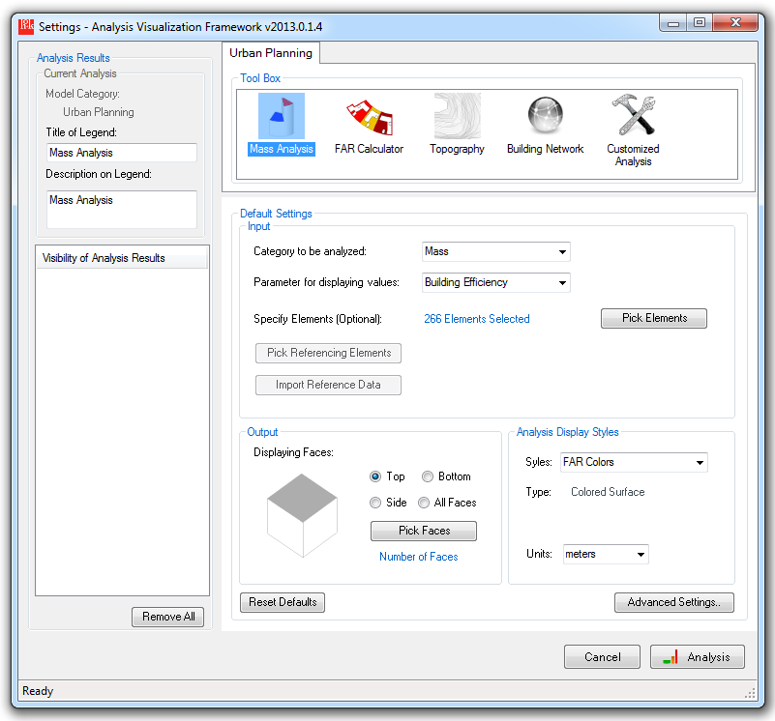

* + 1. ***Analysis Result***

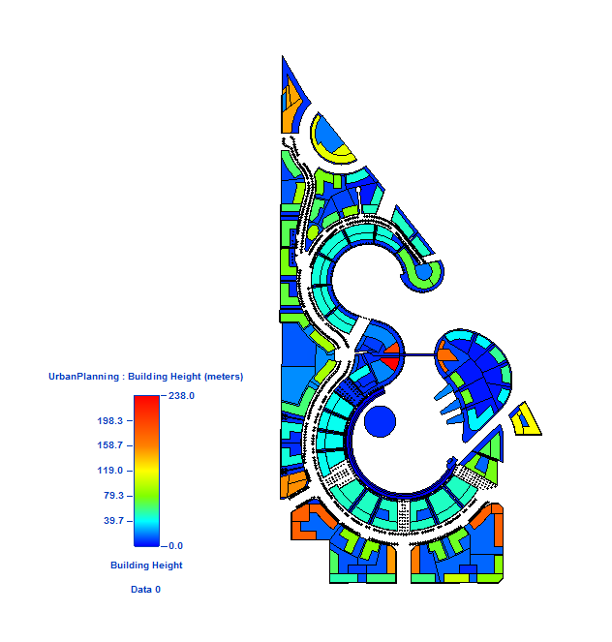

* + 1. ***Displaying Options***

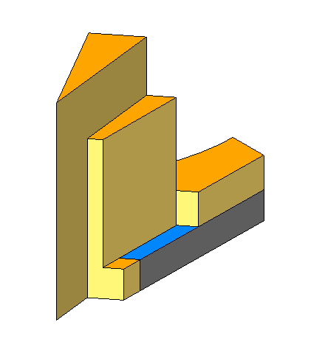 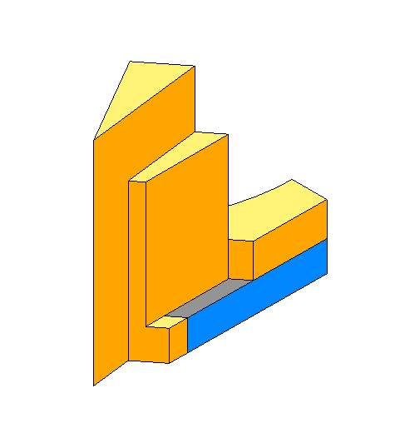 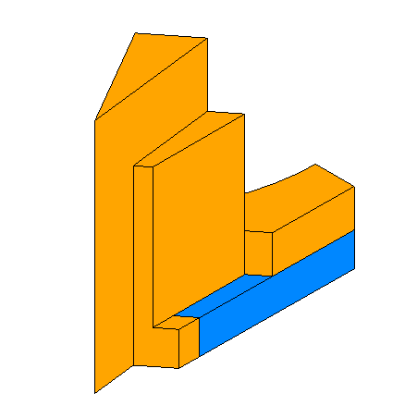

*Option 1. Top Faces Option 2. Side Faces Option 3. All Faces*

* + 1. ***Advanced Settings***

If you want to create multiple sets of values and visualizing the data into different layers of the analysis result, go to the advanced settings and manipulate the parameters through the UI. These multiple sets of values will be accumulated on each singular UV point.

* Select Parameters: Define multiple parameters to be stored on the visualized result as different layers.

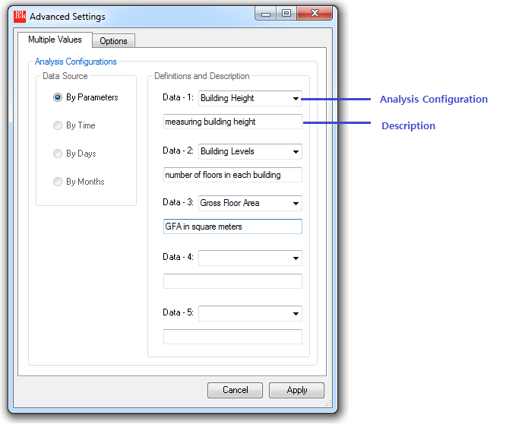

* Choose an Analysis Configuration: in the previous example, three parameters will make three layers of the analysis result. When you select the analysis result, and drop down the Analysis Configuration parameter, you will see the three configuration names on the lists, Building height, Building Levels, Gross floor Area. Depending on the selection of the analysis configuration, the title and description of the legend will be updated accordingly.

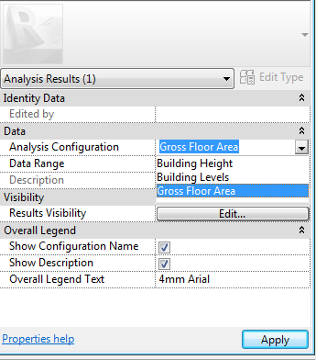 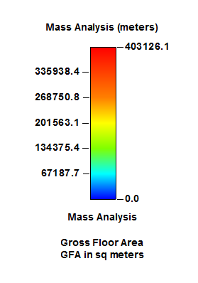

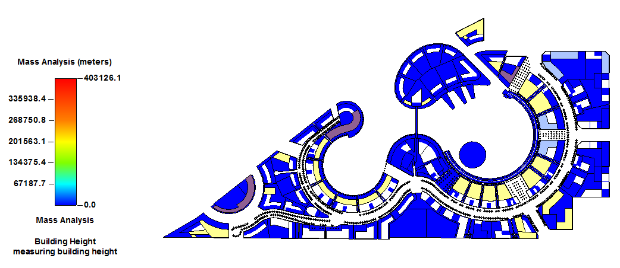

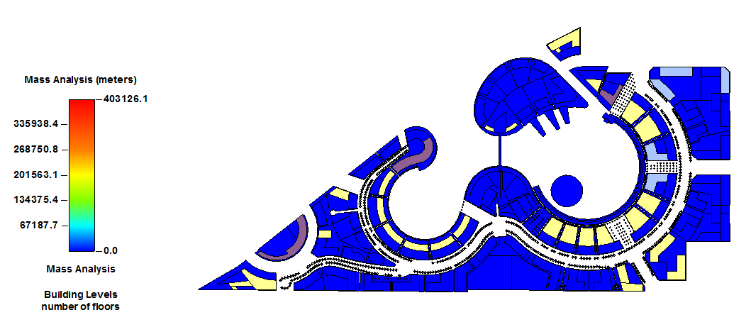

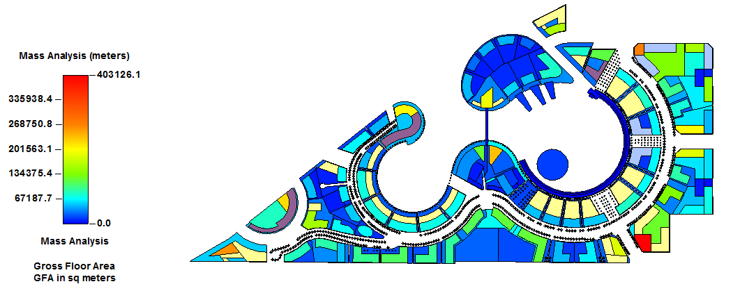

* + 1. ***Limitation***

Setting multiple values on the same point would be not appropriate for the variation of parameter, if their type of units and range of double values vary.

For example, let’s assume we have selected three parameters, Building Height, Building Level, Gross Floor Area, like above. Once the display setting define the maximum value within the result of Gross Floor Area, it may not be recovered back for Building Height and Building Level which has much smaller maximum value than Gross Floor Area. As a result, results that have narrow range of values cannot be differentiated by different colors.

The best scenario is to differentiate the values by time factors, because the range of values will be consistent.

## FAR Calculator

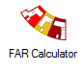

This tool will calculate Floor Area Ratio (FAR), the ratio of a building’s total floor area to the size of the parcel of land, and the store the calculated values in the FAR parameter of each Area element created for the parcel of land.  The Analysis tool will use these FAR values to display the data with gradient colored surfaces.

* + 1. ***Default Settings***

|  |  |
| --- | --- |
| Settings | Values |
| Default Category | Areas |
| Category Options | Areas, Mass |
| Default Parameter Selection | FAR |
| Displaying Face on | Top |
| Allowance to Set Reference | False |
| Reference Category | Null |
| Reference Description | Null |
| Default Units | none |

* + 1. ***Model Requirements***
* Area Parameters: District Code (filled in), Plot Code (filled in), FAR (to be filled)
* Mass Parameters: District Code (to be filled), Plot Code (to be filled)

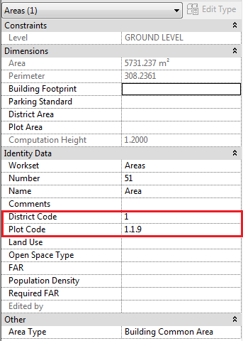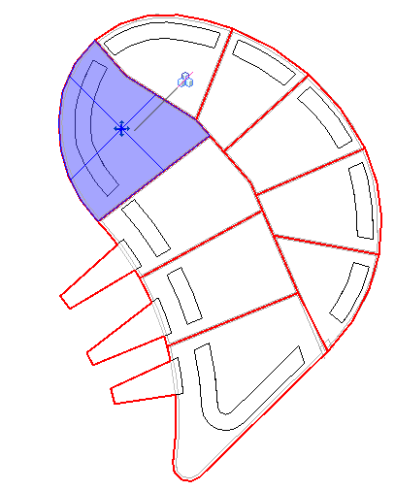

* + 1. ***Walkthrough***
* **Fill in Parameters**: make sure you have an appropriate urban design project that has plot areas and building masses with the appropriate plot information (Plot Code and District Code) filled in.
* **Run with Default Settings**: Select the FAR calculator in the tool box and click the Analysis button remaining the default setting. (do not modify the settings for this version, more options and flexibility will be added for future development)

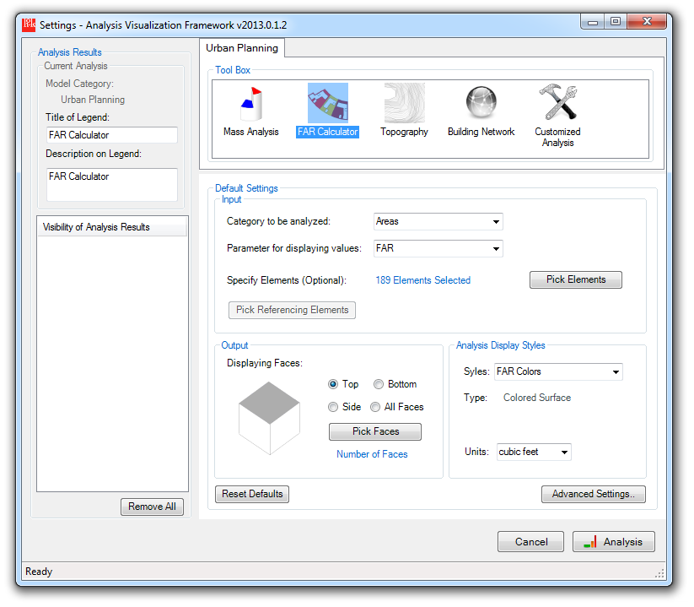

* + 1. ***Analysis Result***

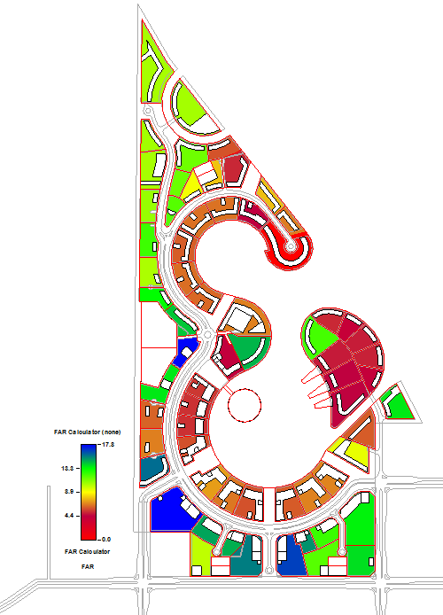

* Mass Parameters: This tool will find building Mass elements placed on each plot Area elements, and transfer the value of District Code and Plot Code from the area element to the mass element. This transaction will be based on the geometry of the model elements, therefore each building element should be placed on top of an appropriate area element.

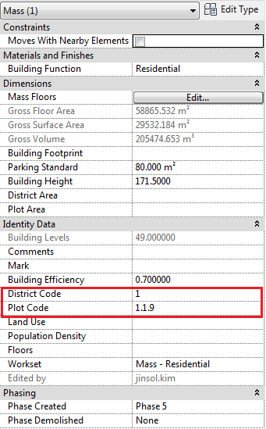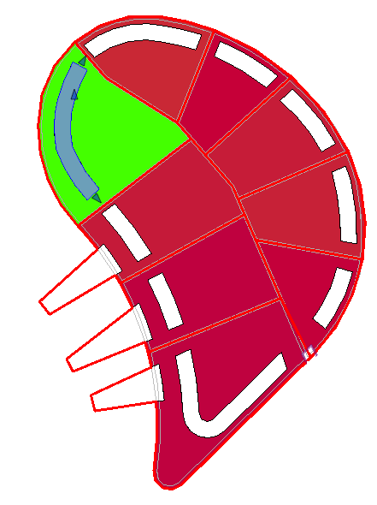

- Area Parameters: Calculated FAR values will be written in the Area parameters.

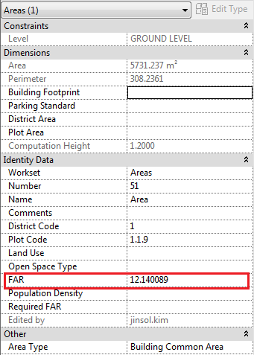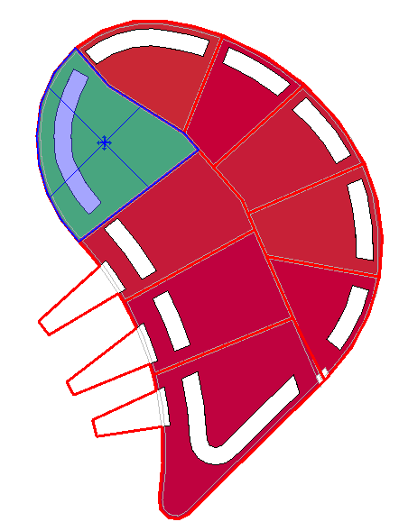

## Topography (For Future Development)

In Revit, a topography surface consists of interior points, boundary points and geometric meshes. All interior points defined by users contain elevation values of each point. Using these values, the result of slope and aspect analysis will be displayed on top of the topography surface.

* + 1. ***Default Settings***

|  |  |
| --- | --- |
| Settings | Values |
| Default Category | Topography |
| Category Options | Topography, Mass, Generic Models |
| Default Parameter Selection | Null |
| Displaying Face on | Top |
| Allowance to Set Reference | False |
| Reference Category | Null |
| Reference Description | Null |
| Default Units | none |

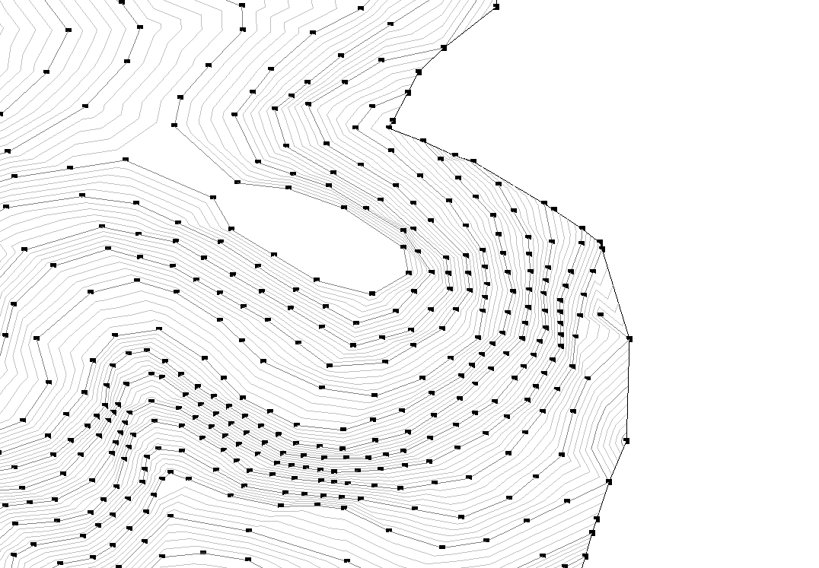

## Building Network (For Future Development)

This tool will be suited for spatial analysis on urban street networks. The analysis result will be computed by either metric distance or topological distance.

* + 1. ***Default Settings***

|  |  |
| --- | --- |
| Settings | Values |
| Default Category | Mass |
| Category Options | Mass, Generic Models |
| Default Parameter Selection | Null |
| Displaying Face on | Top |
| Allowance to Set Reference | False |
| Reference Category | Null |
| Reference Description | Null |
| Default Units | none |

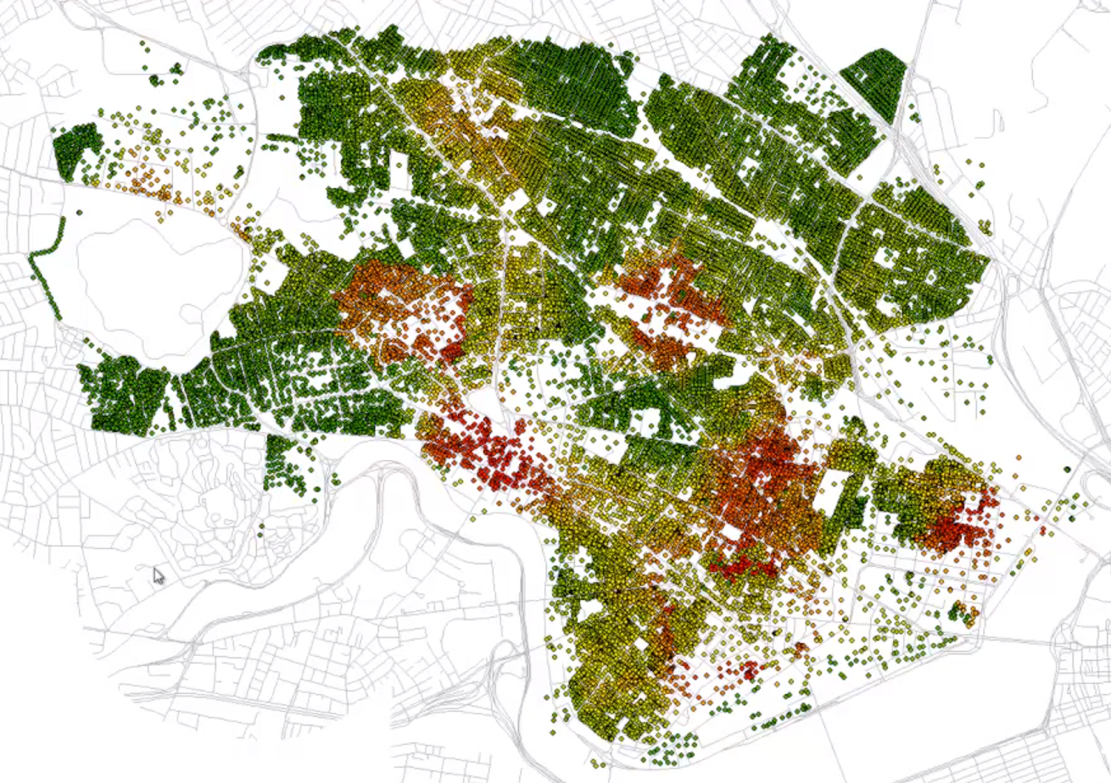

Reference:

City Form Lab, Urban Network Analysis: A Toolbox for ArcGIS 10

<http://cityform.mit.edu/projects/urban-network-analysis.html>

# ***Architecture***

## 2.1 Façade Analysis (for Future Development)

In curtain wall system, individual panels will be painted with gradient colors to indicate the result of the structural analysis such as the pressure of wind.

## 2.2 Heat Map (for Future Development)

The average temperature of rooms will vary depending on the number of lighting fixtures installed, human factor, area of windows and the direction of windows facing. Each individual room will be colored by the temperature.

# ***Interior Design***

## Radiance Analysis

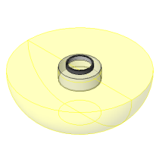

This tool will support data visualization with analysis results obtained from Diva for Rhino onto Revit model. The DIVA for Rhino is a day lighting and energy modeling plug-in for the Rhino. Once model elements are built in Revit, the geometric information can be imported to Rhino to run the radiance analysis using DIVA for Rhino. Meanwhile, the result of analysis will be formatted as .dat which contains locations of xyz data points including the calculated values, so then this tool will import those values and distribute them onto the corresponding point of the location when creating a gradient colored surface.

Website: <http://diva4rhino.com/>

* + 1. ***Default Settings***

|  |  |
| --- | --- |
| Settings | Values |
| Default Category | Rooms |
| Category Options | Rooms, Floors, Spaces |
| Default Parameter Selection | Null |
| Displaying Face on | Bottom |
| Allowance to Set Reference | True |
| Reference Category | Null |
| Reference Description | Specify lighting fixtures, otherwise it will include all as default. |
| Default Units | none |

* + 1. ***Model Requirements***

***Revit Model***

An appropriate room with walls, windows, floors and ceiling should be defined.

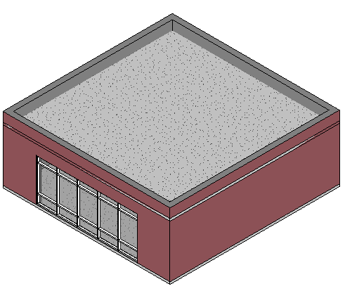

***Rhino Model***

The geometry of Revit model should be imported to Rhino in order to run the radiance analysis using Diva for Rhino. After the completion of the analysis, you will get the .dat file.

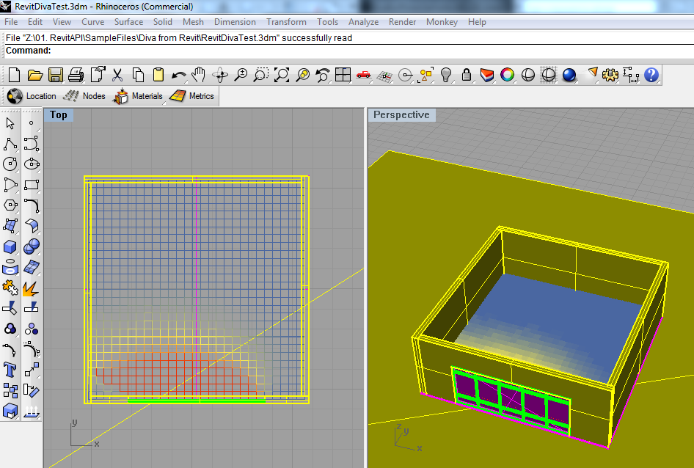

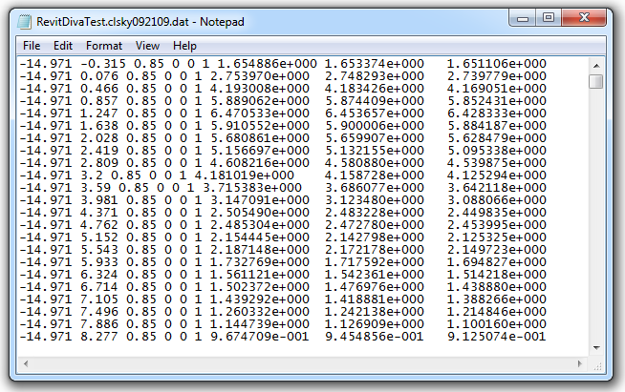

* + 1. ***Walkthrough***
* **Import Reference Data:** anopen file dialog will ask you to assign the .dat file that contains the result data originally generated from the current Revit model.
* **Remain the Default Setting (recommended)**

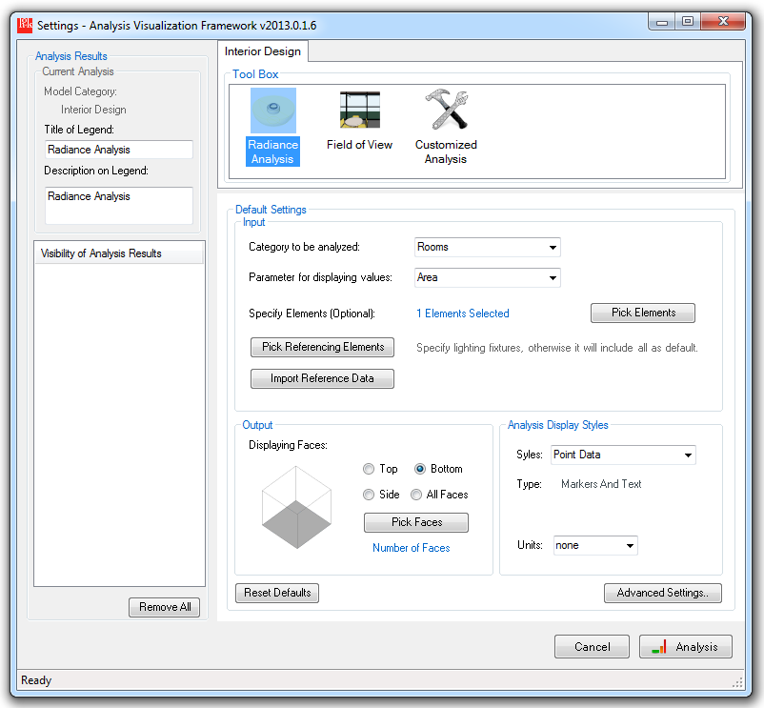

* + 1. ***Analysis Result***

You can get colored points either in 3D views or 2D plans.

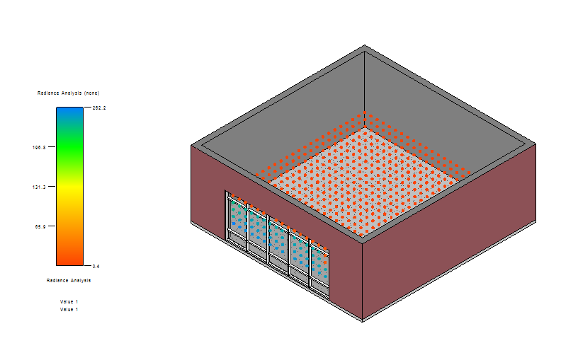

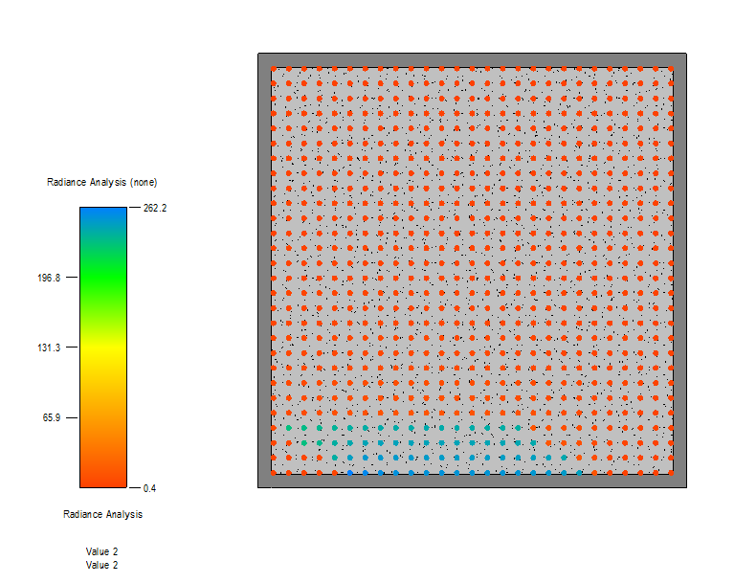

## Field of View

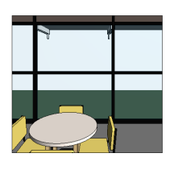

This tool is developed for the visibility analysis that defines isovist field (Benedikt 1979) – the volume of space visible from a given point in space, together with a specification of location of that point. Even though currently Ecotect has the similar functionality of doing this analysis, this tool was introduced for the seamless data transfer in Revit platform having more flexibility of the modification of model geometry with more simplified workflow.

* + 1. ***Default Settings***

|  |  |
| --- | --- |
| Settings | Values |
| Default Category | Floors |
| Category Options | Floors, Rooms |
| Default Parameter Selection | Null |
| Displaying Face on | Top |
| Allowance to Set Reference | True |
| Reference Category | Windows |
| Reference Description | Pick a window element |
| Default Units | none |

* + 1. ***Model Requirements***

Interior rooms should be bounded by exterior or interior walls.

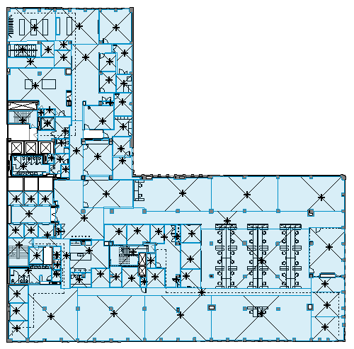

* + 1. ***Walkthrough***

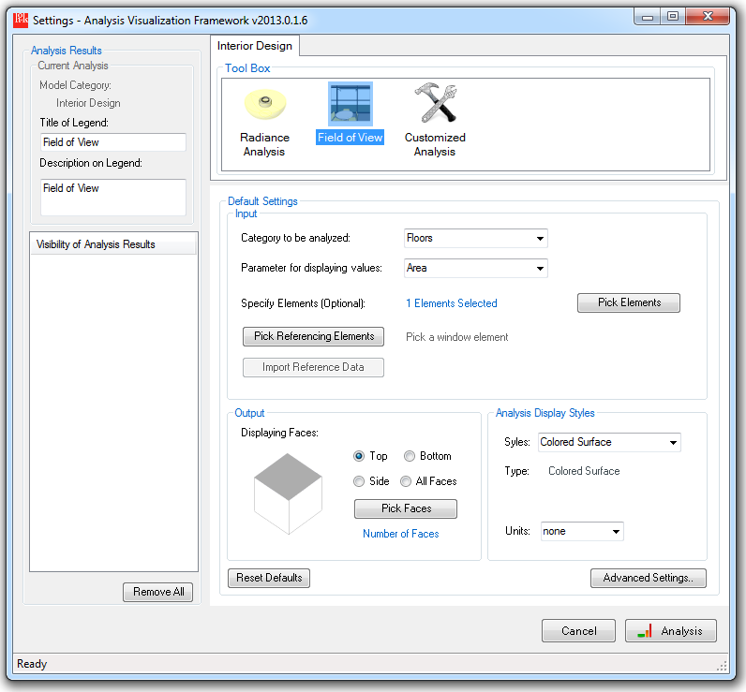

* ***Place the point of view:*** If you haven’t placed a family instance to define the point of view, you will be asked to insert an instance in the model.
* 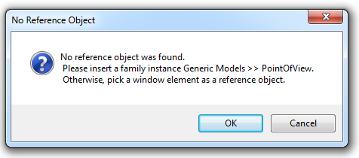

This tool will automatically load the family, so you will be able to find the family named PointOfView in Generic Models.

Make sure the level is same as the level of rooms. You may need to adjust the offset parameter to define the height of the view.

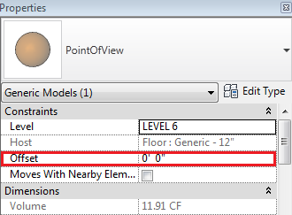

* ***Select a Category:*** Select one of category options between Floors and Rooms.
* ***Pick Elements:*** If you want to confine the input, select some rooms or floors depending on what you select from the category.
* ***Pick Referencing Elements:*** Pick a window element if that should be set as the point of view.
  + 1. ***Analysis Result***

In order to measure the depth of the visibility, it will count the number of intervening walls from the point of view to a parameterized point on the field. Only one exception will be made when the invisible line pass through transparent walls like curtain walls, then it won’t be counted as an intervening wall. For the material standpoint, this mechanism should be developed further.

